**CST8215_310 Assignment II – Movie Shop**

**Done By Ilgun, Abdullah Zekı & Do, Trung Minh**

**Adding the DDL Statements**

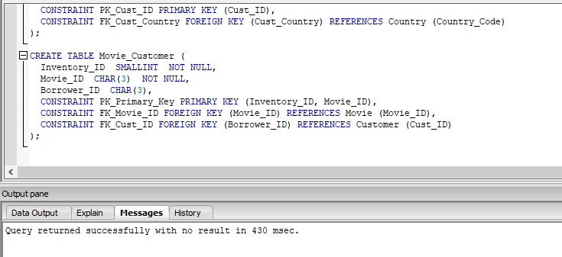

**Adding the DML Statements**

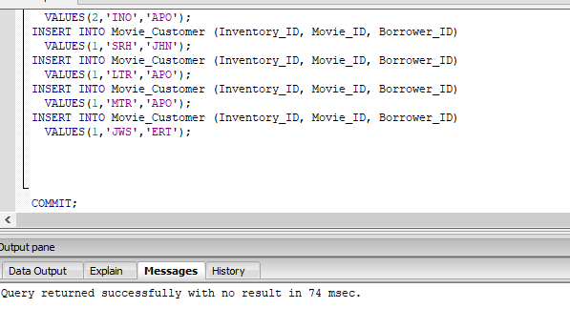

**Select Statements**

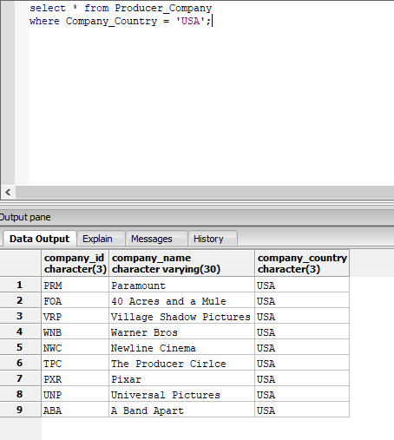

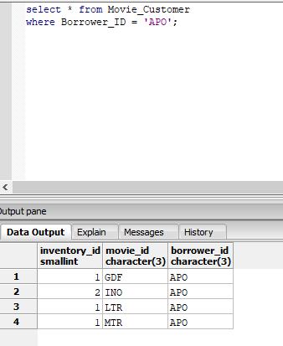

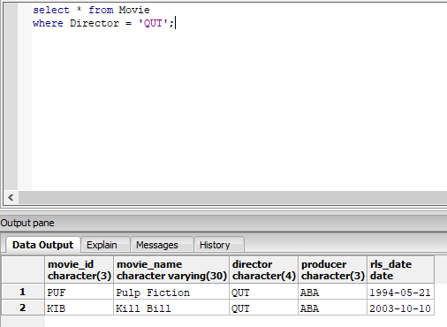

**Union**

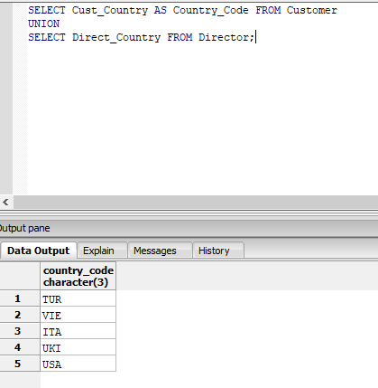

**Joins**

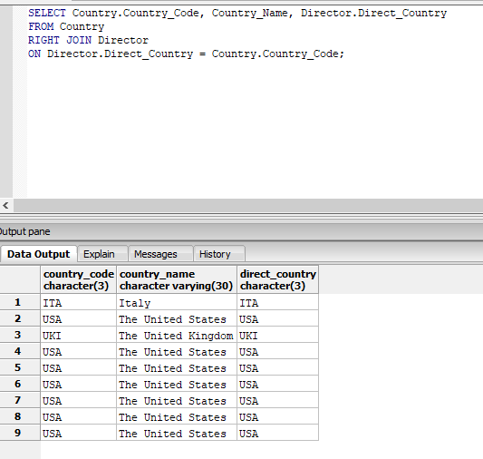

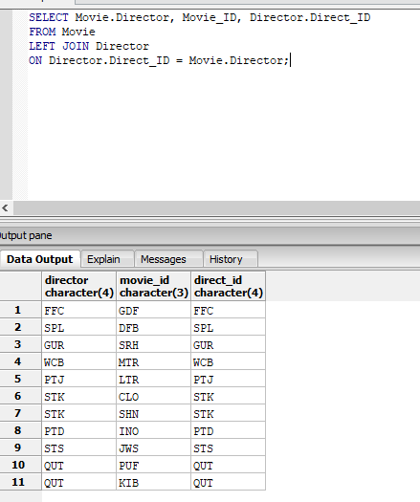

**Metadata**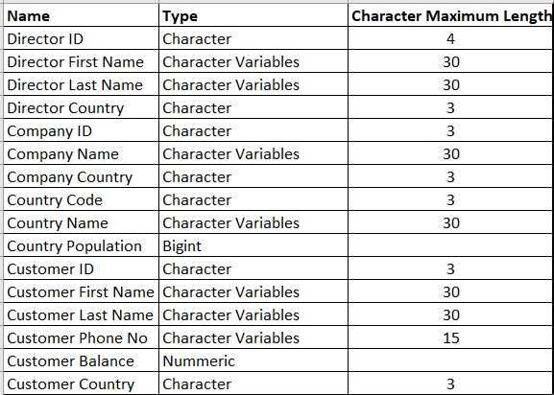

**Indexes**

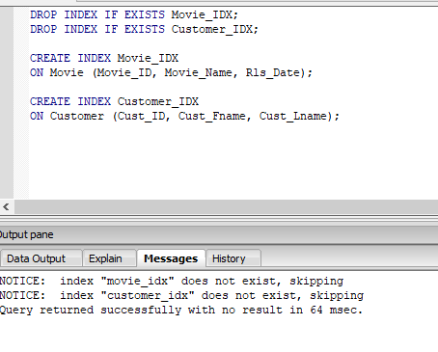

**Views**

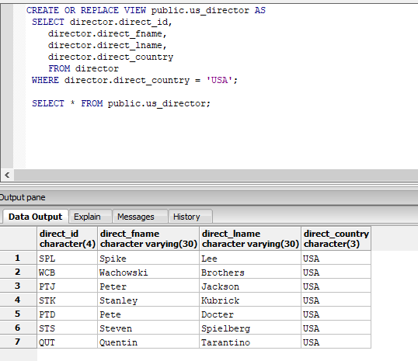

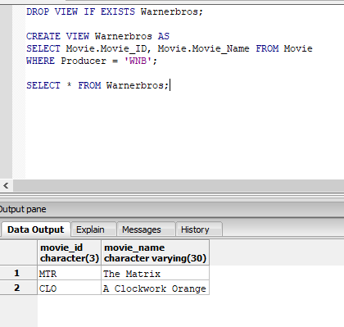

**Reverse Engineered ERD**

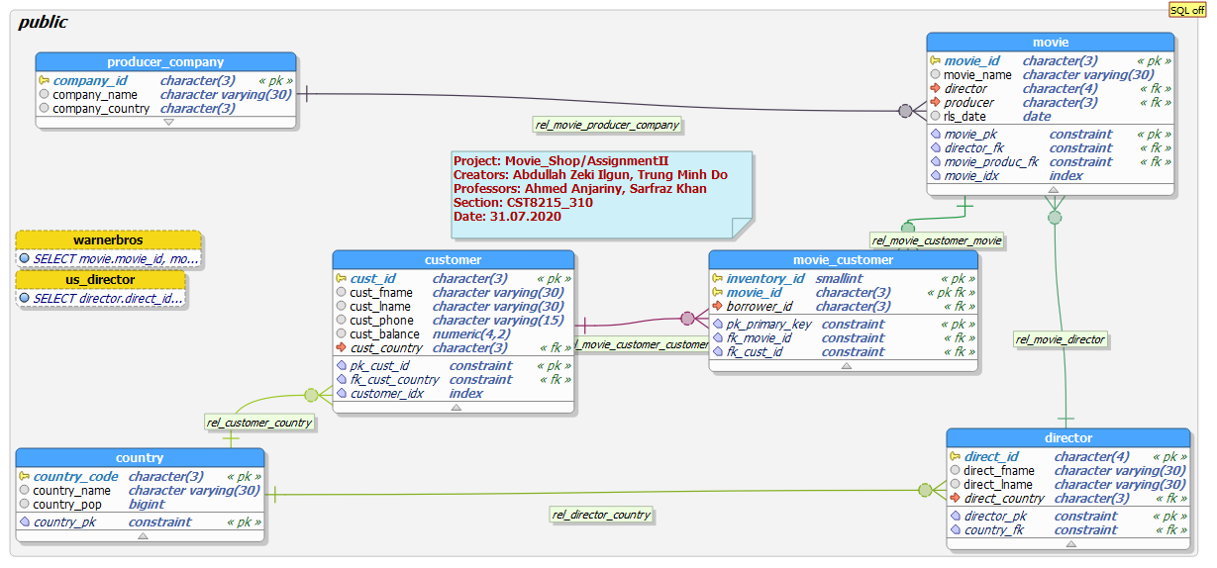

**Milestone**

**Abstract:**

It’s a primitive movie rental store as it was popular in many years ago before the raising of Netflix. Subscribers of this store are considered as customers. There are movie, customer, producer company, director, and country informations as the entities in the database behind the store.

**Business Rules:**

1. A movie is directed by one and only one director.
2. Lead producer is considered as the producer company of a movie in this database. So, a movie can be produced by one company.
3. A movie can be rented by zero or many customers.
4. There can be more than one movies which have the same name. They’re differed by inventory id’s.
5. A producer company produces one or many movies.
6. A producer company is located in one and only one country.
7. Zero or many directors may come from a country.
8. A director comes from one and only one country.
9. A director can make one or many movies. (They’re not considered as a director unless they’ve made at least one movie.)
10. A movie can be directed by one and only one director.
11. A customer can be from one and only one country, and a country can have zero or many customers.
12. A customer is still a customer even though he doesn’t rent a movie since he’s basically a subscriber.

**ERD on Paper**

